**PDF 문서를 HTML로 변환하기 자료 조사**

**Pdf2Swf.exe 사용법**

SWFTools 에서 다운받아 프로그램을 설치한다. (pdf2swf.exe 사용하기 위함)

<http://www.swftools.org/download.html>

한글 설정을 위해 <http://www.foolabs.com/xpdf/download.html> 에서 xpdf-korean 다운로드 (xpdf-korean.tar)

압축 해제 후 add-to-xpdfrc 파일을 아래 참고로 하여 편집 :

#----- begin Korean support package (2011-sep-02)

cidToUnicode Adobe-Korea1 F:\xpdf\language\korean\Adobe-Korea1.cidToUnicode

unicodeMap ISO-2022-KR F:\xpdf\language\korean\ISO-2022-KR.unicodeMap

cMapDir Adobe-Korea1 F:\xpdf\language\korean\CMap

toUnicodeDir F:\xpdf\language\korean\CMap

#fontFileCC Adobe-Korea1 /usr/..../batang.ttf"

#fontFileCC Unidocs-Korea1 /usr/..../batang.ttf"

#----- end Korean support package

displayNamedCIDFontTT Gulim C:\Windows\Fonts\gulim.ttc

#displayNamedCIDFontT1 AppleMyungjo C:\Windows\Fonts\AdobeMyungjoStd-Medium.otf ⇒ otf 폰트 맵핑

displayCIDFontTT Adobe-Korea1 C:\Windows\Fonts\batang.ttc

설정 후 아래와 같이 명령 콘솔에서 실행 :  
설정이 잘못되어 있다면 오류가 뜨며, 오류가 뜨지 않으면 1.swf 생성되는데, 그 파일을 열어 결과를 확인하면 됩니다.

(사용예)

*pdf2swf -f -s languagedir=<add-to-xpdfrc 파일이 있는 디렉토리 경로> -s flashversion=10 <입력 pdf 파일경로> -o %.swf*

pdf2swf -f -s languagedir="F:/xpdf/language/korean" -s flashversion=10 "TouchGestureGuide.pdf" -o "output/name_%.swf"

**옵션 :** <http://wiki.swftools.org/wiki/Main_Page>

**Usage: pdf2swf [-options] file.pdf -o file.swf**

-h , --help Print short help message and exit

-V , --version Print version info and exit

-o , --output file.swf Direct output to file.swf. If file.swf contains '%' (file%.swf), then each page goes to a separate file.

-p , --pages range Convert only pages in range with range e.g. 1-20 or 1,4,6,9-11 or

-P , --password password Use password for deciphering the pdf.

-v , --verbose Be verbose. Use more than one -v for greater effect.

-z , --zlib Use Flash 6 (MX) zlib compression.

-i , --ignore Allows pdf2swf to change the draw order of the pdf. This may make the generated

-j , --jpegquality quality Set quality of embedded jpeg pictures to quality. 0 is worst (small), 100 is best (big). (default:85)

-s , --set param=value Set a SWF encoder specific parameter. See pdf2swf -s help for more information.

-w , --samewindow When converting pdf hyperlinks, don't make the links open a new window.

-t , --stop Insert a stop() command in each page.

-T , --flashversion num Set Flash Version in the SWF header to num.

-F , --fontdir directory Add directory to the font search path.

-b , --defaultviewer Link a standard viewer to the swf file.

-l , --defaultloader Link a standard preloader to the swf file which will be displayed while the main swf is loading.

-B , --viewer filename Link viewer filename to the swf file.

-L , --preloader filename Link preloader filename to the swf file.

-q , --quiet Suppress normal messages. Use -qq to suppress warnings, also.

-S , --shapes Don't use SWF Fonts, but store everything as shape.

-f , --fonts Store full fonts in SWF. (Don't reduce to used characters).

-G , --flatten Remove as many clip layers from file as possible.

-I , --info Don't do actual conversion, just display a list of all pages in the PDF.

-Q , --maxtime n Abort conversion after n seconds. Only available on Unix.

**PDF device global parameters:**

fontdir=<dir> a directory with additional fonts

font=<filename> an additional font filename

pages=<range> the range of pages to convert (example: pages=1-100,210-)

zoom=<dpi> the resultion (default: 72)

languagedir=<dir> Add an xpdf language directory

multiply=<times> Render everything at <times> the resolution

poly2bitmap Convert graphics to bitmaps

bitmap Convert everything to bitmaps

**SWF Parameters:**

**SWF layer options:**

jpegsubpixels=<pixels> resolution adjustment for jpeg images (same as jpegdpi, but in pixels)

ppmsubpixels=<pixels resolution adjustment for lossless images (same as ppmdpi, but in pixels)

subpixels=<pixels> shortcut for setting both jpegsubpixels and ppmsubpixels

drawonlyshapes convert everything to shapes (currently broken)

ignoredraworder allow to perform a few optimizations for creating smaller SWFs

linksopennewwindow make links open a new browser window

linktarget target window name of new links

linkcolor=<color) color of links (format: RRGGBBAA)

linknameurl Link buttons will be named like the URL they refer to (handy for iterating through links with actionscript)

storeallcharacters don't reduce the fonts to used characters in the output file

enablezlib switch on zlib compression (also done if flashversion>=6)

bboxvars store the bounding box of the SWF file in actionscript variables

dots Take care to handle dots correctly

reordertags=0/1 (default: 1) perform some tag optimizations

internallinkfunction=<name> when the user clicks a internal link (to a different page) in the converted file, this actionscript function is called

externallinkfunction=<name> when the user clicks an external link (e.g. http://www.foo.bar/) on the converted file, this actionscript function is called

disable_polygon_conversion never convert strokes to polygons (will remove capstyles and joint styles)

caplinewidth=<width> the minimum thichness a line needs to have so that capstyles become visible (and are converted)

insertstop put an ActionScript "STOP" tag in every frame

protect add a "protect" tag to the file, to prevent loading in the Flash editor

flashversion=<version> the SWF fileversion (6)

framerate=<fps> SWF framerate

minlinewidth=<width> convert horizontal/vertical boxes smaller than this width to lines (0.05)

simpleviewer Add next/previous buttons to the SWF

animate insert a showframe tag after each placeobject (animate draw order of PDF files)

jpegquality=<quality> set compression quality of jpeg images

splinequality=<value> Set the quality of spline convertion to value (0-100, default: 100).

disablelinks Disable links.

**참고**

<http://www.igorcosta.org/?p=231>  
<http://blog.naver.com/hongse99?Redirect=Log&logNo=20146724450>  
<http://itzone.tistory.com/443>

**FlexPaper 세팅 방법**   
(<http://flexpaper.devaldi.com/docs_publishing_with_PHP.jsp>)

GPL License Flash 버젼 다운로드 : <http://flexpaper.devaldi.com/download/>

설명에 따라 FlexPaper_1.5.8_flash 압축 해제한 디렉토리 아래의 pdf/config/config.ini.win.php 파일을 자신의 환경에 맞게 편집 (운영 체제가 윈도우가 아니면 config.ini.nix.php)

한글 인식을 위해 storeallcharacters -s languagedir=\"{xpdf 경로}\" 추가한다.

다음은, 웹서버에서 FlexPaper_1.5.8_flash 압축 해제한 디렉토리를 브라우저에서 접근 가능하도록 설정하고 http://{도메인}/FlexPaper/php/ 와 같이 접근하면 셋업이 시작되는데

* PDF 저장 경로
* 생성될 SWF 저장 경로
* 관리자 아이디, 암호

설정하면 셋업이 완료되며 로그인 후 PDF 를 업로드 하면 e-book이 보인다. 참고로, PDF 저장 경로로 지정한 곳에 PDF를 복사하여 넣어도 인식 된다.

자세한 내용은 매뉴얼을 참고할 것. (<http://flexpaper.devaldi.com/docs_converting.jsp>)

**Publishing to HTML4**

* pdf2json   
  각 페이지에 포함된 텍스트를 Json 형식으로 추출 (<https://code.google.com/p/pdf2json/>)  
  <https://github.com/modesty/pdf2json>
* SWFTools (swfrender.exe)  
  swf를 이미지로 변환 (<http://swftools.org/>)
* mupdf (mudraw.exe)  
  pdf파일에서 각 페이지를 이미지로 변환 ([http://mupdf.com](http://mupdf.com/))

**pdf2json**

<https://code.google.com/p/pdf2json/>

**pdf2json Paper.pdf -enc UTF-8 -compress Paper.js**

**Usage: pdf2json [options] <PDF-file> [<output-file>]**  
  -f <int>          : first page to convert  
  -l <int>          : last page to convert  
  -compress         : Use compressed mode  
  -q                : dont print any messages or errors  
  -h                : print usage information  
  -help             : print usage information  
  -i                : ignore images  
  -noframes         : use standard output  
  -xml              : output for XML post-processing  
  -split <int>      : split the output into separate files on every X page.   
                      use '%' as part of output file name to specify where page number should appear (e.g. Paper_%.js)  
  -hidden           : output hidden text  
  -enc <string>     : output text encoding name  
  -v                : print copyright and version info  
  -opw <string>     : owner password (for encrypted files)  
  -upw <string>     : user password (for encrypted files)

(사용예)

*Pdf2json –split 1 –enc “UTF-8” –f <변환 시작 페이지> -l <변환 끝페이지> <pdf파일 경로> %.json*

pdf2json –split 1 –enc UTF-8 a.pdf page%.json

(주의)

* 10페이지 이하의 pdf에서 의미 없는 10.json 파일이 생성된다. 10페이지 이상의 pdf에서는 해당 페이지의 json 파일만 정상적으로 생성된다.
* %.json 구문이 2부터 카운트된다.
* enc 옵션을 빠뜨리면 한글은 추출되지 않는다.

JSON 데이터 샘플 (pdf2json.exe)

폰트 추출이 안됨 대신 단어 별로 데이터가 추출됨

[  
 {  
 "number":1,  
 "pages":7,  
 "height":1188,  
 "width":918,  
 "fonts":[  
 {"fontspec":"0","size":"14","family":"Times","color":"#231f20"},  
 {"fontspec":"1","size":"10","family":"Times","color":"#110f0d"},  
 {"fontspec":"2","size":"48","family":"Times","color":"#231f20"},  
 {"fontspec":"3","size":"18","family":"Times","color":"#231f20"},  
 {"fontspec":"4","size":"12","family":"Times","color":"#231f20"},  
 {"fontspec":"5","size":"19","family":"Times","color":"#231f20"},  
 {"fontspec":"6","size":"19","family":"Times","color":"#231f20"},  
 {"fontspec":"7","size":"14","family":"Times","color":"#7b7979"},  
 {"fontspec":"8","size":"13","family":"Times","color":"#d3d2d2"},  
 {"fontspec":"9","size":"14","family":"Times","color":"#ffffff"},  
 {"fontspec":"10","size":"16","family":"Times","color":"#ffffff"},  
 {"fontspec":"11","size":"10","family":"Times","color":"#7b7979"}  
 ],  
 "text":[  
 {"top":333,"left":85,"width":30,"height":20,"font":0,"data":"Tap"},  
 {"top":333,"left":288,"width":60,"height":20,"font":0,"data":"Double "},  
 {"top":333,"left":348,"width":25,"height":20,"font":0,"data":"tap"},  
 {"top":333,"left":490,"width":38,"height":20,"font":0,"data":"Drag"},  
 {"top":333,"left":693,"width":37,"height":20,"font":0,"data":"Flick"},  
 {"top":556,"left":85,"width":44,"height":20,"font":0,"data":"Pinch"},  
 {"top":556,"left":287,"width":56,"height":20,"font":0,"data":"Spread"},  
 {"top":556,"left":490,"width":45,"height":20,"font":0,"data":"Press"},  
 {"top":556,"left":693,"width":49,"height":20,"font":0,"data":"Press "},  
 {"top":556,"left":742,"width":34,"height":20,"font":0,"data":"and "},  
 {"top":556,"left":776,"width":25,"height":20,"font":0,"data":"tap"},  
 {"top":793,"left":85,"width":49,"height":20,"font":0,"data":"Press "},  
 {"top":793,"left":134,"width":34,"height":20,"font":0,"data":"and "},  
 {"top":793,"left":168,"width":36,"height":20,"font":0,"data":"drag"},  
 {"top":793,"left":404,"width":53,"height":20,"font":0,"data":"Rotate"},  
 {"top":870,"left":174,"width":17,"height":14,"font":1,"data":"OR"},  
 {"top":870,"left":573,"width":17,"height":14,"font":1,"data":"OR"},  
 {"top":870,"left":750,"width":17,"height":14,"font":1,"data":"OR"},  
 {"top":105,"left":180,"width":158,"height":60,"font":2,"data":"Touch "},  
 {"top":105,"left":338,"width":369,"height":60,"font":2,"data":"GestureREFERENCE "},  
 .................  
 ]  
 }  
]

**mupdf**

**usage: mudraw [options] input [pages]**

-o - output filename (%d for page number) supported formats: pgm, ppm, pam, png, pbm  
 -p - password  
 -r - resolution in dpi (default: 72)  
 -w - width (in pixels) (maximum width if -r is specified)  
 -h - height (in pixels) (maximum height if -r is specified)  
 -f - fit width and/or height exactly (ignore aspect)  
 -a save alpha channel (only pam and png)  
 -b - number of bits of antialiasing (0 to 8)  
 -g render in grayscale  
 -m show timing information  
 -t show text (-tt for xml, -ttt for more verbose xml)  
 -x show display list  
 -d disable use of display list  
 -5 show md5 checksums  
 -R - rotate clockwise by given number of degrees  
 -G gamma gamma correct output  
 -I invert output  
 -l print outline  
 -j - Output mujstest file  
 -i ignore errors and continue with the next file  
 pages comma separated list of ranges

(사용예)

*mudraw –r72 –o %d.png <pdf 파일 경로>  
mudraw –ttt <pdf 파일 경로> 1 > 옵션결과(-ttt).txt*

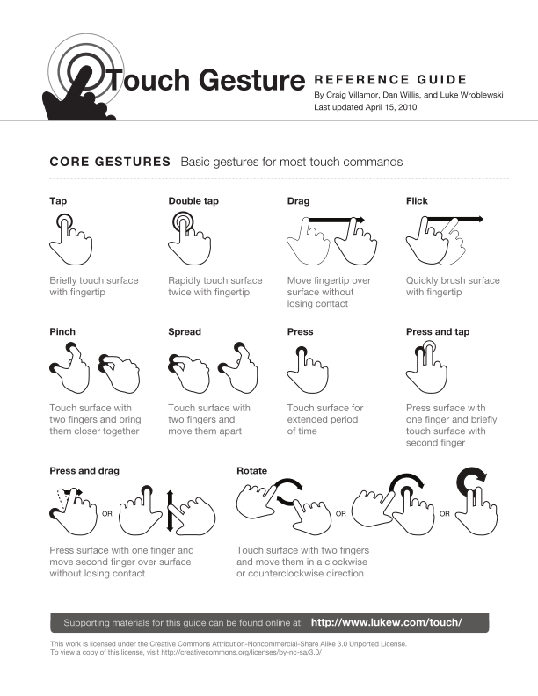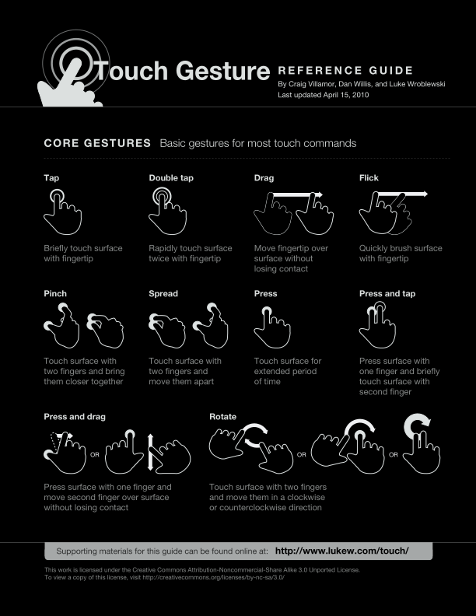

* **폰트 추출**폰트는 mutool.exe로 뽑아낼 수 있다.   
  폰트 이름은 추출된 폰트 파일명에서 하이픈(-) 다음 숫자를 제외한 이름이 된다.  
  (예) WKIKGZ+HelveticaNeue-Bold-0303.ttf 🡪 WKIKGZ+HelveticaNeue-Bold

**테스트**

* **mudraw -t 옵션 결과** (텍스트만 추출)

Tap Double tap Drag Flick  
Pinch Spread Press Press and tap  
Press and drag Rotate  
OR  
OR OR  
Touch GestureR E F E R E N C E G U I D E  
By Craig Villamor, Dan Willis, and Luke Wroblewski  
Last updated April 15, 2010  
CORE GESTURES Basic gestures for most touch commands

……

* **mudraw -tt 옵션 결과** (텍스트에 폰트만 적용됨, 위치지정 x)

<style>  
 body{background-color:gray;margin:12tp;}  
 div.page{background-color:white;margin:6pt;padding:6pt;}  
 div.block{border:1px solid gray;margin:6pt;padding:6pt;}  
 p{margin:0;padding:0;}  
</style>  
<style>  
 span.s10{font-family:"HelveticaNeue";font-size:8.03542pt;}  
 span.s9{font-family:"HelveticaNeue-Bold";font-size:12pt;font-weight:bold;}  
 span.s8{font-family:"HelveticaNeue";font-size:10.5pt;}  
 span.s7{font-family:"HelveticaNeue";font-size:11pt;}  
 span.s6{font-family:"HelveticaNeue-Light";font-size:14pt;}  
 span.s5{font-family:"HelveticaNeue-Bold";font-size:14pt;font-weight:bold;}  
 span.s4{font-family:"HelveticaNeue";font-size:9.45pt;}  
 span.s3{font-family:"HelveticaNeue-Bold";font-size:13.95pt;font-weight:bold;}  
 span.s2{font-family:"HelveticaNeue-Bold";font-size:33.0515pt;font-weight:bold;}  
 span.s1{font-family:"HelveticaNeue";font-size:8pt;}  
 span.s0{font-family:"HelveticaNeue-Bold";font-size:11pt;font-weight:bold;}  
</style>  
<body>  
 <div class="page">  
 <div class="block"><p>  
 <span><span class="s0">Tap Double tap Drag Flick</span></span>  
 </p></div>  
 <div class="block"><p>  
 <span><span class="s0">Pinch Spread Press Press and tap</span></span>  
 </p></div>  
 <div class="block"><p>  
 <span><span class="s0">Press and drag Rotate</span></span>  
 </p></div>  
 <div class="block"><p>  
 <span><span class="s1">OR</span></span>  
 </p></div>  
 <div class="block"><p>  
 <span><span class="s1">OR OR</span></span>  
 </p></div>  
 <div class="block"><p>  
 <span><span class="s2">Touch Gesture</span><span class="s3">R E F E R E N C E G U I D E</span></span>  
 </p></div>  
 <div class="block"><p>  
 <span><span class="s4">By Craig Villamor, Dan Willis, and Luke Wroblewski</span></span>  
 <span><span class="s4">Last updated April 15, 2010</span></span>  
 </p></div>  
 <div class="block"><p>  
 <span><span class="s5">CORE GESTURES </span><span class="s6">Basic gestures for most touch commands</span></span>  
 </p></div>  
 </div>  
……………….  
</body>

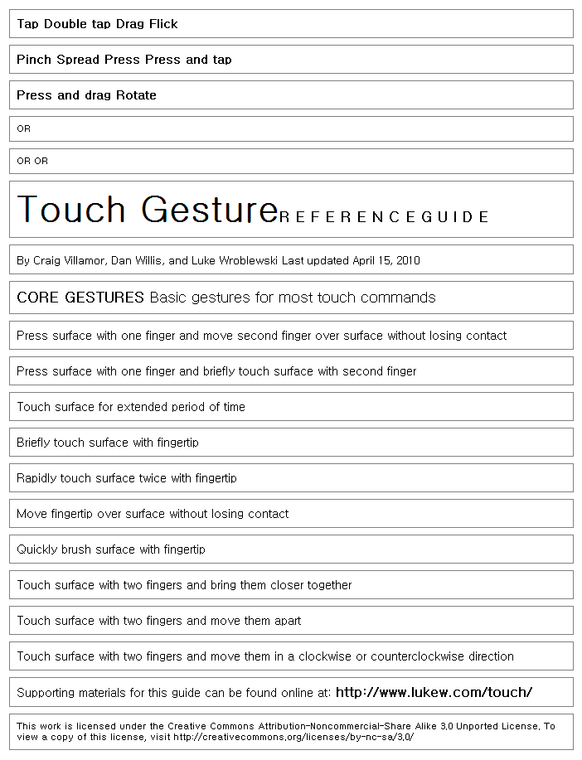

* **mudraw -ttt 옵션 결과** (한자씩 분리되어 나타남)

<?xml version="1.0"?>  
<document name="TouchGestureGuide.pdf">  
 <page>  
 <block bbox="56.5581 221.873 486.955 234.985">  
 <line bbox="56.5581 221.873 486.955 234.985">  
 <span bbox="56.5581 221.873 486.955 234.985" font="HelveticaNeue-Bold" size="11">  
 <char bbox="56.5581 221.873 63.2787 234.985" c="T"/>  
 <char bbox="63.2791 221.873 69.5927 234.985" c="a"/>  
 <char bbox="69.5931 221.873 76.3137 234.985" c="p"/>  
 <char bbox="189.548 221.873 191.748 234.985" c=" "/>  
 <char bbox="191.748 221.873 199.899 234.985" c="D"/>  
 <char bbox="199.899 221.873 206.62 234.985" c="o"/>  
 <char bbox="206.62 221.873 213.143 234.985" c="u"/>  
 <char bbox="213.143 221.873 219.864 234.985" c="b"/>  
 <char bbox="219.864 221.873 222.702 234.985" c="l"/>  
 <char bbox="222.702 221.873 229.016 234.985" c="e"/>  
 <char bbox="229.016 221.873 232.074 234.985" c=" "/>  
 <char bbox="232.074 221.873 235.946 234.985" c="t"/>  
 <char bbox="235.946 221.873 242.26 234.985" c="a"/>  
 <char bbox="242.26 221.873 248.981 234.985" c="p"/>  
 ……………  
 </span>  
 </line>  
 </block>  
 <block bbox="56.5691 370.593 534.453 383.705">  
 <line bbox="56.5691 370.593 534.453 383.705">  
 <span bbox="56.5691 370.593 534.453 383.705" font="HelveticaNeue-Bold" size="11">  
 <char bbox="56.5691 370.593 63.9055 383.705" c="P"/>  
 <char bbox="63.9061 370.593 66.7439 383.705" c="i"/>  
 <char bbox="66.7441 370.593 73.2666 383.705" c="n"/>  
 <char bbox="73.2671 370.593 79.5807 383.705" c="c"/>  
 <char bbox="79.5811 370.593 86.1036 383.705" c="h"/>  
 <char bbox="189.339 370.593 191.539 383.705" c=" "/>  
 <char bbox="191.539 370.593 198.678 383.705" c="S"/>  
 <char bbox="198.678 370.593 205.399 383.705" c="p"/>  
 <char bbox="205.399 370.593 209.678 383.705" c="r"/>  
 <char bbox="209.678 370.593 215.992 383.705" c="e"/>  
 <char bbox="215.992 370.593 222.306 383.705" c="a"/>  
 <char bbox="222.306 370.593 229.027 383.705" c="d"/>  
 ……………..  
 </span>  
 </line>  
 </block>  
 .................  
 </page>  
</document>

한글인 경우 다음과 같이 표기됨을 주의한다. ( HTML Entity : &#x Hex 코드 ; )  
(C/C++/Java source code : “\uC6D0”)

<span bbox="209.4 104.526 231 118.89" font="맑은고딕,Bold" size="10.8">  
<char bbox="209.4 104.526 220.2 118.89" c="&#xc6d0;"/>  
<char bbox="220.2 104.526 231 118.89" c="&#xbcf8;"/>  
</span>

*/\**

*캐릭터 정보 검색 : http://graphemica.com/*

*(예) 원 : http://www.fileformat.info/info/unicode/char/c6d0/index.htm*

*HTML Entity (decimal) &#50896;*

*HTML Entity (hex) &#xc6d0;*

*UTF-8 (hex) 0xEC 0x9B 0x90 (ec9b90)*

*UTF-8 (binary) 11101100:10011011:10010000*

*UTF-16 (hex) 0xC6D0 (c6d0)*

*UTF-16 (decimal) 50,896*

*UTF-32 (hex) 0x0000C6D0 (c6d0)*

*UTF-32 (decimal) 50,896*

*\*/*

*//원 : U+C6D0 -> 0xC6D0(16진수), 50896(10진수)*

**var** str:String = **"&#xc6d0;"**;

*//본 : U+BCF8 -> 0xbcf8(16진수), 48376(10진수)*

*//str = "&#xbcf8;";*

*// &#는 유니코드를 불러오는 시작어, 뒷번호는 약속된 문자를 불러오는 호출문자*

*//&#xc6d0; -- > &#(유니코드) + x(16진수) + c6d0 + ;*

*// hex : 0x + c6d0*

**var** decimal:String = (0xc6d0).toString(10);

**var** num:Number = parseInt(decimal); *// decimal : (&#)50896*

**var** char:String = String.fromCharCode(num)

**trace**(char);

* **mudraw -x 옵션 결과 (display list 드로잉 포맷으로 표현됨)** – 무슨 포맷인지는 확인이 필요함

<?xml version="1.0"?>  
<document name="TouchGestureGuide.pdf">  
 <page number="1">  
 <clip_path winding="nonzero" matrix="1 0 0 -1 0 792" contentbbox="0 34.2783 612 747.723">  
 <moveto x="0" y="792"/>  
 <lineto x="612" y="792"/>  
 <lineto x="612" y="0"/>  
 <lineto x="0" y="0"/>  
 <closepath/>  
 </clip_path>  
 <fill_text font="WKIKGZ+HelveticaNeue-Bold" wmode="0" colorspace="DeviceCMYK" color="0 0 0 1" matrix="1 0 0 -1 0 792" trm="11 0 0 11">  
 <g ucs="T" gid="59" x="56.5581" y="559.402" />  
 <g ucs="a" gid="72" x="63.2791" y="559.402" />  
 <g ucs="p" gid="87" x="69.5931" y="559.402" />  
 <g ucs="D" gid="43" x="191.748" y="559.402" />  
 <g ucs="o" gid="86" x="199.899" y="559.402" />  
 <g ucs="u" gid="92" x="206.62" y="559.402" />  
 <g ucs="b" gid="73" x="213.143" y="559.402" />  
 <g ucs="l" gid="83" x="219.864" y="559.402" />  
 <g ucs="e" gid="76" x="222.702" y="559.402" />  
 <g ucs=" " gid="3" x="229.016" y="559.402" />  
 <g ucs="t" gid="91" x="232.074" y="559.402" />  
 <g ucs="a" gid="72" x="235.946" y="559.402" />  
 <g ucs="p" gid="87" x="242.26" y="559.402" />  
 <g ucs="D" gid="43" x="326.938" y="559.402" />  
 <g ucs="r" gid="89" x="335.089" y="559.402" />  
 <g ucs="a" gid="72" x="339.368" y="559.402" />  
 <g ucs="g" gid="78" x="345.682" y="559.402" />  
 <g ucs="F" gid="45" x="462.128" y="559.402" />  
 <g ucs="l" gid="83" x="468.651" y="559.402" />  
 <g ucs="i" gid="80" x="471.489" y="559.402" />  
 <g ucs="c" gid="74" x="474.327" y="559.402" />  
 <g ucs="k" gid="82" x="480.641" y="559.402" />  
 <g ucs="P" gid="55" x="56.5691" y="410.682" />  
 <g ucs="i" gid="80" x="63.9061" y="410.682" />  
 <g ucs="n" gid="85" x="66.7441" y="410.682" />  
 <g ucs="c" gid="74" x="73.2671" y="410.682" />  
 <g ucs="h" gid="79" x="79.5811" y="410.682" />  
 .......................  
 </fill_text>  
 <fill_path winding="nonzero" colorspace="DeviceCMYK" color="0.695 0.672 0.637 0.738" matrix="1 0 0 -1 67.9209 419.832">  
 <moveto x="0" y="0"/>  
 <curveto x1="-0.603" y1="-3.02" x2="-3.61" y2="-4.992" x3="-6.72" y3="-4.408"/>  
 <curveto x1="-9.829" y1="-3.824" x2="-11.86" y2="-0.902" x3="-11.257" y3="2.117"/>  
 <curveto x1="-10.654" y1="5.137" x2="-7.646" y2="7.109" x3="-4.538" y3="6.525"/>  
 <curveto x1="-1.429" y1="5.938" x2="0.604" y2="3.02" x3="0" y3="0"/>  
 </fill_path>  
 <stroke_path linewidth="1" miterlimit="4" linecap="0,0,0" linejoin="0" colorspace="DeviceCMYK" color="0.695 0.672 0.637 0.738" matrix="1 0 0 -1 67.9209 419.832">  
 <moveto x="0" y="0"/>  
 <curveto x1="-0.603" y1="-3.02" x2="-3.61" y2="-4.992" x3="-6.72" y3="-4.408"/>  
 <curveto x1="-9.829" y1="-3.824" x2="-11.86" y2="-0.902" x3="-11.257" y3="2.117"/>  
 <curveto x1="-10.654" y1="5.137" x2="-7.646" y2="7.109" x3="-4.538" y3="6.525"/>  
 <curveto x1="-1.429" y1="5.938" x2="0.604" y2="3.02" x3="0" y3="0"/>  
 <closepath/>  
 </stroke_path>  
  
 <fill_path winding="nonzero" colorspace="DeviceCMYK" color="0.695 0.672 0.637 0.738" matrix="1 0 0 -1 86.4976 396.284">  
 <moveto x="0" y="0"/>  
 <curveto x1="-0.603" y1="-3.021" x2="-3.612" y2="-4.994" x3="-6.72" y3="-4.408"/>  
 <curveto x1="-9.83" y1="-3.822" x2="-11.86" y2="-0.9" x3="-11.258" y3="2.119"/>  
 <curveto x1="-10.656" y1="5.14" x2="-7.648" y2="7.113" x3="-4.538" y3="6.526"/>  
 <curveto x1="-1.43" y1="5.94" x2="0.602" y2="3.019" x3="0" y3="0"/>  
 </fill_path>  
 <stroke_path linewidth="1" miterlimit="4" linecap="0,0,0" linejoin="0" colorspace="DeviceCMYK" color="0.695 0.672 0.637 0.738" matrix="1 0 0 -1 86.4976 396.284">  
 <moveto x="0" y="0"/>  
 <curveto x1="-0.603" y1="-3.021" x2="-3.612" y2="-4.994" x3="-6.72" y3="-4.408"/>  
 <curveto x1="-9.83" y1="-3.822" x2="-11.86" y2="-0.9" x3="-11.258" y3="2.119"/>  
 <curveto x1="-10.656" y1="5.14" x2="-7.648" y2="7.113" x3="-4.538" y3="6.526"/>  
 <curveto x1="-1.43" y1="5.94" x2="0.602" y2="3.019" x3="0" y3="0"/>  
 <closepath/>  
 </stroke_path>  
 ..................  
 <pop_clip/>  
 </page>  
</document>

한글인 경우 다음과 같이 표기됨을 주의한다. ( ASCll : U+Hex 코드 )

<g ucs="U+C6D0" gid="2130" x="209.4" y="725.72" /> <!-- U+C6D0 : 원-->  
<g ucs="U+BCF8" gid="1599" x="220.2" y="725.72" /> <!-- U+C6D0 : 본-->

처리 방법은 위의 경우와 같다

*// 참고 Hex 코드 만들기*

*// http://blog.naver.com/PostView.nhn?blogId=jjungsuk&logNo=120130737693&redirect=Dlog&widgetTypeCall=true*

**public** **class** Hex  
 {  
 **public** **static** **function** toArray(hex:String):ByteArray {  
 hex = hex.replace(**/\s|:/gm**,**''**);  
 **var** a:ByteArray = **new** ByteArray;  
 **if** (hex.length&1==1) hex=**"0"**+hex;  
 **for** (**var** i:uint=0;i<hex.length;i+=2) {  
 a[i/2] = parseInt(hex.substr(i,2),16);  
 }  
 **return** a;  
 }

**public** **static** **function** fromArray(array:ByteArray, colons:Boolean=**false**):String {  
 **var** s:String = **""**;  
 **for** (**var** i:uint=0;i<array.length;i++) {  
 s+=(**"0"**+array[i].toString(16)).substr(-2,2);  
 **if** (colons) {  
 **if** (i<array.length-1) s+=**":"**;  
 }  
 }  
 *//encodeURI* **return** s;  
 }

// a UTF-8 string decoded from hex  
 **public** **static** **function** toString(hex:String):String {  
 **var** a:ByteArray = toArray(hex);  
 a.position = 0;  
 **return** a.readUTFBytes(a.length);  
 }

// a hex string encoded from the UTF-8 string str  
 **public** **static** **function** fromString(str:String, colons:Boolean=**false**):String {  
 **var** a:ByteArray = **new** ByteArray;  
 a.writeUTFBytes(str);  
 **return** fromArray(a, colons);  
 }  
 }  
   
 *// 사용법*   
 Hex.toString(“원”); // ec9b90  
 Hex.fromString(“ec9b90”); // 원

*/\**

*var str1:String = "flex";*

*//public charCodeAt(index:Number) : Number*

*//index가 지정하는 문자를 나타내는 0에서 65535 사이의 16비트 정수를 반환*

*//index가 0부터 string.length - 1 사이의 숫자가 아니면 NaN이 반환*

*//trace( str.charCodeAt(0) ); // 102;*

*// 문자열을 16비트 정수값으로 변환*

*var strNum:Number = 0;*

*strNum += str1.charCodeAt(0) << 24;*

*strNum += str1.charCodeAt(1) << 16;*

*strNum += str1.charCodeAt(2) << 8;*

*strNum += str1.charCodeAt(3);*

*trace( strNum );*

*// 16비트 정수값을 문자열로 변환*

*// & 비트 AND 연산자 :숫자의 비트 표현을 비교한 후 같은 자리의 비트가 둘 다 1인 경우에만 1을 반환*

*trace( String.fromCharCode((strNum >> 24 ))); //f*

*trace( String.fromCharCode((strNum >> 16 ) & 0xFF)); //l*

*trace( String.fromCharCode((strNum >> 8 ) & 0xFF)); //e*

*trace( String.fromCharCode(strNum & 0xFF)); //x*

*\*/*

**pdftohtml 사용한 변환**

<http://sourceforge.net/projects/pdftohtml/>  
<http://sourceforge.net/p/pdftohtml/discussion/150220/thread/daa9a0bf/>

* 윈도우용은 찾기가 힘들다. sourceforge에서 말고 다음에서 pdftohtml을 다운 받는다.  
  poppler-utils-0.15 : <http://www.outsch.org/2010/09/20/poppler-utils-0-15-for-windows/>
* Ghostscript 설치   
  Ghostscript 가 설치되어있지 않으면 페이지 이미지가 생성되지 않는다.  
  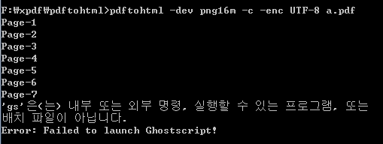
* pdftohtml에서 내부적으로 gs를 호출하므로 설치 후 다음과 같이 설정해준다.  
  환경 변수에 ghostscript 경로를 잡아준다.  
  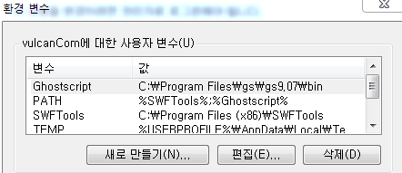
* ghostscript 설치폴더로 가서 gswin64.exe파일을 복사하여 gs.exe를 생성한다.  
  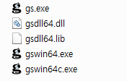

**Usage: pdftohtml [options] <PDF-file> [<html-file> <xml-file>]**

pdftohtml version 0.15.0  
Copyright 2005-2010 The Poppler Developers - <http://poppler.freedesktop.org>  
Copyright 1999-2003 Gueorgui Ovtcharov and Rainer Dorsch  
Copyright 1996-2004 Glyph & Cog, LLC

-f <int> : first page to convert  
 -l <int> : last page to convert  
 -q : don't print any messages or errors  
 -h : print usage information  
 -help : print usage information  
 -p : exchange .pdf links by .html  
 -c : generate complex document  
 -i : ignore images  
 -noframes : generate no frames  
 -stdout : use standard output  
 -zoom <fp> : zoom the pdf document (default 1.5)  
 -r <int> : resolution to render the pdf document (default 72)  
 -xml : output for XML post-processing  
 -hidden : output hidden text  
 -nomerge : do not merge paragraphs (블록이 아닌 라인단위로 잘림)  
 -enc <string> : output text encoding name  
 -dev <string> : output device name for Ghostscript (png16m, jpeg etc)  
 -fmt <string> : image file format for Splash output (png or jpg)  
 -v : print copyright and version info  
 -opw <string> : owner password (for encrypted files)  
 -upw <string> : user password (for encrypted files)  
 -nodrm : override document DRM settings

(사용예)

pdftohtml –dev png16m –c –enc UTF-8 a.pdf name.html  
pdftohtml –dev png16m –xml –zoom 1 –enc UTF-8 a.pdf name.xml

* **Html 출판  
  -** 아래와 같이 텍스트 선택 가능함.  
  **-** 폰트 설정은 안되어있음  
  **-** 폰트 없는 이미지로 배경화면 만든 후 텍스트 배치하는 방식임  
  **-** 단어 별로 추출됨 블록 유지됨  
  **-** 배경 이미지 뽑아낼 때 ghostscript 툴을 사용함  
  **-** 이미지 품질이 좋지 않음

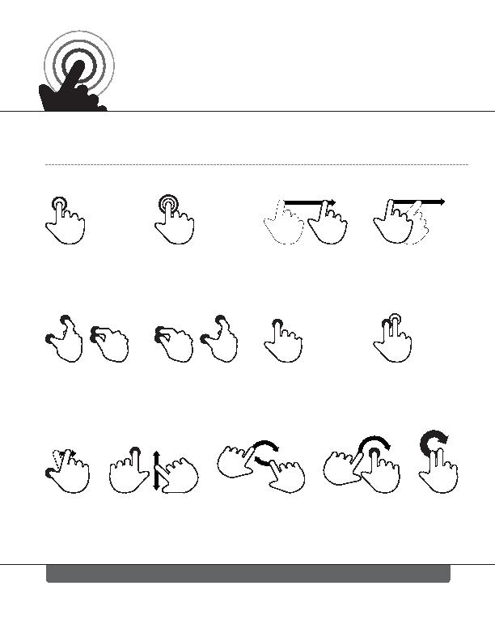 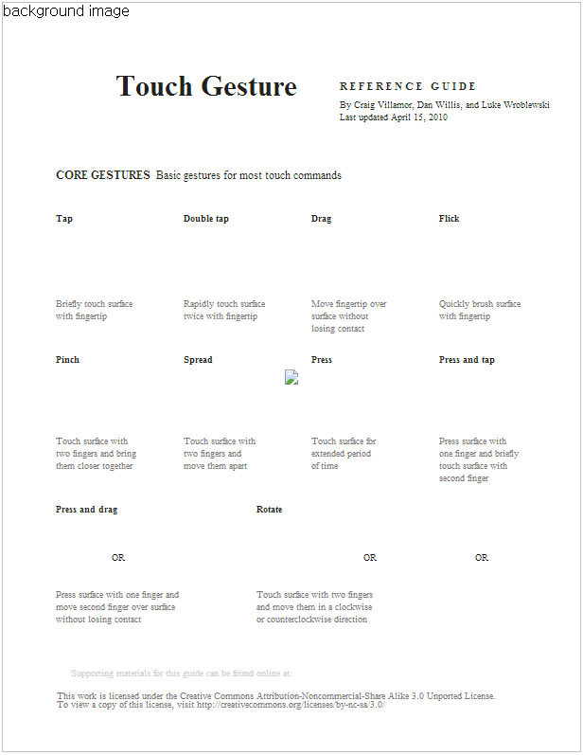  
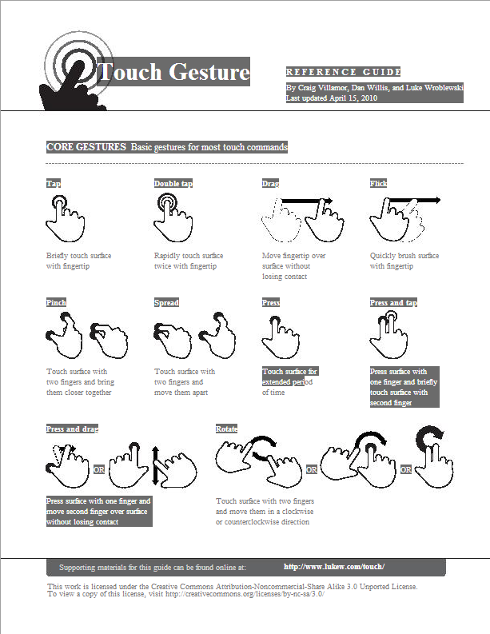

<!DOCTYPE HTML PUBLIC "-//W3C//DTD HTML 4.01 Transitional//EN">  
<HTML>  
 <HEAD>  
 <TITLE>Page 1</TITLE>  
 <META http-equiv="Content-Type" content="text/html; charset=UTF-8">  
 <DIV style="position:relative;width:612;height:792;">  
 <STYLE type="text/css">  
 <!--  
 .ft0{font-size:9px;font-family:Times;color:#231f20;}  
 .ft1{font-size:6px;font-family:Times;color:#100f0d;}  
 .ft2{font-size:31px;font-family:Times;color:#231f20;}  
 .ft3{font-size:11px;font-family:Times;color:#231f20;}  
 .ft4{font-size:7px;font-family:Times;color:#231f20;}  
 .ft5{font-size:12px;font-family:Times;color:#231f20;}  
 .ft6{font-size:12px;font-family:Times;color:#231f20;}  
 .ft7{font-size:9px;font-family:Times;color:#7b7879;}  
 .ft8{font-size:8px;font-family:Times;color:#d3d2d2;}  
 .ft9{font-size:9px;font-family:Times;color:#ffffff;}  
 .ft10{font-size:10px;font-family:Times;color:#ffffff;}  
 .ft11{font-size:6px;font-family:Times;color:#7b7879;}  
 .ft12{font-size:7px;line-height:13px;font-family:Times;color:#231f20;}  
 .ft13{font-size:9px;line-height:13px;font-family:Times;color:#7b7879;}  
 .ft14{font-size:6px;line-height:9px;font-family:Times;color:#7b7879;}  
 -->  
 </STYLE>  
 </HEAD>  
 <BODY bgcolor="#A0A0A0" vlink="blue" link="blue">  
 <IMG width="612" height="792" src="a.htm001.jpeg" alt="background image">  
 <DIV style="position:absolute;top:222;left:57"><nobr><span class="ft0"><b>Tap</b></span></nobr></DIV>  
 <DIV style="position:absolute;top:222;left:192"><nobr><span class="ft0"><b>Double tap</b></span></nobr></DIV>  
 <DIV style="position:absolute;top:222;left:327"><nobr><span class="ft0"><b>Drag</b></span></nobr></DIV>  
 <DIV style="position:absolute;top:222;left:462"><nobr><span class="ft0"><b>Flick</b></span></nobr></DIV>  
 <DIV style="position:absolute;top:371;left:57"><nobr><span class="ft0"><b>Pinch</b></span></nobr></DIV>  
 <DIV style="position:absolute;top:371;left:192"><nobr><span class="ft0"><b>Spread</b></span></nobr></DIV>  
 <DIV style="position:absolute;top:371;left:327"><nobr><span class="ft0"><b>Press</b></span></nobr></DIV>  
 <DIV style="position:absolute;top:371;left:462"><nobr><span class="ft0"><b>Press and tap</b></span></nobr></DIV>  
 <DIV style="position:absolute;top:529;left:57"><nobr><span class="ft0"><b>Press and drag</b></span></nobr></DIV>  
 <DIV style="position:absolute;top:529;left:269"><nobr><span class="ft0"><b>Rotate</b></span></nobr></DIV>  
 <DIV style="position:absolute;top:580;left:116"><nobr><span class="ft1">OR</span></nobr></DIV>  
 <DIV style="position:absolute;top:580;left:382"><nobr><span class="ft1">OR</span></nobr></DIV>  
 <DIV style="position:absolute;top:580;left:500"><nobr><span class="ft1">OR</span></nobr></DIV>  
 <DIV style="position:absolute;top:70;left:120"><nobr><span class="ft2"><b>Touch Gesture</b></span></nobr></DIV>  
 <DIV style="position:absolute;top:82;left:357"><nobr><span class="ft3"><b>R&nbsp;E&nbsp;F&nbsp;E&nbsp;R&nbsp;E&nbsp;N&nbsp;C&nbsp;E&nbsp;&nbsp;&nbsp;G&nbsp;U&nbsp;I&nbsp;D&nbsp;E</b></span></nobr></DIV>  
 <DIV style="position:absolute;top:102;left:357"><nobr><span class="ft12">By Craig Villamor, Dan Willis, and Luke Wroblewski<br>Last updated April 15, 2010</span></nobr></DIV>

…………………….  
 </BODY>  
</HTML>

* **XML 출판**

<?xml version="1.0" encoding="UTF-8"?>  
<!DOCTYPE pdf2xml SYSTEM "pdf2xml.dtd">  
<pdf2xml>  
 <page number="1" position="absolute" top="0" left="0" height="792" width="612">  
 <fontspec id="0" size="9" family="Times" color="#231f20"/>  
 <fontspec id="1" size="6" family="Times" color="#100f0d"/>  
 <fontspec id="2" size="31" family="Times" color="#231f20"/>  
 <fontspec id="3" size="11" family="Times" color="#231f20"/>  
 <fontspec id="4" size="7" family="Times" color="#231f20"/>  
 <fontspec id="5" size="12" family="Times" color="#231f20"/>  
 <fontspec id="6" size="12" family="Times" color="#231f20"/>  
 <fontspec id="7" size="9" family="Times" color="#7b7879"/>  
 <fontspec id="8" size="8" family="Times" color="#d3d2d2"/>  
 <fontspec id="9" size="9" family="Times" color="#ffffff"/>  
 <fontspec id="10" size="10" family="Times" color="#ffffff"/>  
 <fontspec id="11" size="6" family="Times" color="#7b7879"/>  
 <text top="222" left="57" width="20" height="13" font="0"><b>Tap</b></text>  
 <text top="222" left="192" width="57" height="13" font="0"><b>Double tap</b></text>  
 <text top="222" left="327" width="25" height="13" font="0"><b>Drag</b></text>  
 <text top="222" left="462" width="25" height="13" font="0"><b>Flick</b></text>  
 <text top="371" left="57" width="30" height="13" font="0"><b>Pinch</b></text>  
 <text top="371" left="192" width="37" height="13" font="0"><b>Spread</b></text>  
 <text top="371" left="327" width="30" height="13" font="0"><b>Press</b></text>  
 <text top="371" left="462" width="72" height="13" font="0"><b>Press and tap</b></text>  
 <text top="529" left="57" width="79" height="13" font="0"><b>Press and drag</b></text>  
 <text top="529" left="269" width="35" height="13" font="0"><b>Rotate</b></text>  
 <text top="580" left="116" width="12" height="9" font="1">OR</text>  
 <text top="580" left="382" width="12" height="9" font="1">OR</text>  
 <text top="580" left="500" width="12" height="9" font="1">OR</text>  
 <text top="70" left="120" width="228" height="40" font="2"><b>Touch Gesture</b></text>  
 <text top="82" left="357" width="173" height="17" font="3"><b>R E F E R E N C E G U I D E</b></text>  
 <text top="102" left="357" width="215" height="11" font="4">By Craig Villamor, Dan Willis, and Luke Wroblewski</text>  
………………………  
 </page>  
</pdf2xml>

**CreateJS**

플래시 Extension으로 제공됨

<http://www.adobe.com/kr/products/flash/flash-to-html5.html>   
<http://www.adobe.com/devnet/createjs/articles/getting-started.html>   
<http://tv.adobe.com/search/?q=flash+to+html5&product_id=17&topic_id=&release_id=&t_lid>=

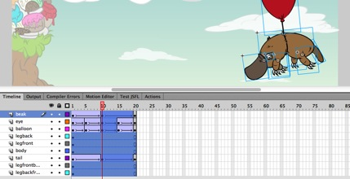

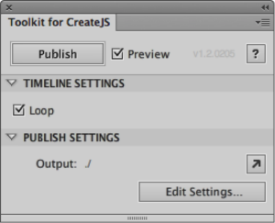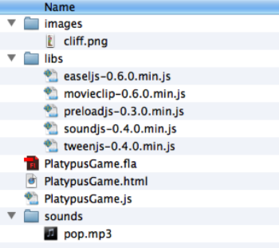

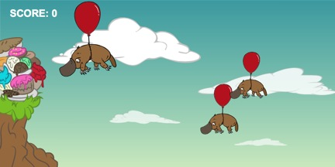

**Google swiffy Beta**

<https://www.google.com/doubleclick/studio/swiffy/>

Flash Extension 또는 온라인 서비스로 변환 할 수 있다.  
SWF 파일을 HTML로 변환 시켜 준다.

**How Swiffy works**

Swiffy converts a [SWF file](http://en.wikipedia.org/wiki/Swf) to an HTML page that contains an efficient representation of the file as a [JSON object](http://en.wikipedia.org/wiki/JSON). The HTML page uses the Swiffy runtime (a JavaScript library) to render the animation using mainly [SVG](http://en.wikipedia.org/wiki/Svg). Compiled ActionScript code is also contained in the JSON file and executed as JavaScript in the browser.

Swf 🡪 json 🡪 runtime.js 🡪 rendering

* Adobe 플래시에 extension 으로 붙여서 쉽게 사용할 수 있음.
* 파일사이즈 limit: 1mb 이상은 변환이 안됩니다. (테스트 필요함)
* JSON 형식에 데이터로 출력 됩니다.   
   <script>  
  swiffyobject = {"tags":[{"id":1,"glyphs":[{"unicode":" ","data":"","advance":285},{"unicode":"%","data":":6u83Fb4c:6e9bbw8bw9ib:7gV6jbW9b7E9bb3C:5E8BbW9BW0Jb:7Gw6Jbv9B5e9Bc:B2Fb5G:5K5eb9C5e9C3mb:0j4d0ob4d9d1k9db7f:3k0Eb5d0E5d3Nb:6I5D5Nb5D9D4K9Dc:77d47db3c:6e9bbv8bv9ib:7gV6jbV9b7E9bb3C:5E9BbW9BW9Ib:7Gw6Jbv9B6e9Bc:3G47Da01D72ga4g:a00d72Gc:C85cb5G:5K5eb9C4e9C3mb:0j4d0ob4d9d1k9db7f:3k0Eb6d0E6d3Nb:6I5D5Nb6D9D5K9Dc","advance":911},{"unicode":".","data":":3i2Ja:2ja3j:a:2Jc","advance":285},{"unicode":"0","data":":81b61Fb3f:5j9eb2d0f2d1xb:0r2D0xb2D0f4J0fb2F:4J0Fb3D0F3D0Xb:1R7d8Xb7c2E9i2Ec:a5Gb0H:3M3db3E3d9G3lb7B9g7B9tb:6t2g98bb1f6g7p6gb0h:3m3Db3e4D9g3Lb7b9G7b8Tb:9JQ3QbP5F5D9Jb9B5D4G9Fb4DX3JXc","advance":570},{"unicode":"1","data":":24c36GbX8d0H8ib7E1e2M6ha:7hb2dO5i6Db2e1C5h2Fa:73ea0i:a:36Gc","advance":570},{"unicode":"2","data":":86b36Gb4J:6P5eb2F4e2G7oa3ijb:9F9c8.....   
  따라서 출력 후 editing이 매우 어려울 듯 합니다.
* **Supported features and browsers**Swiffy uses web standards such as SVG and EcmaScript 5, so over time more browsers will support Swiffy output.  
  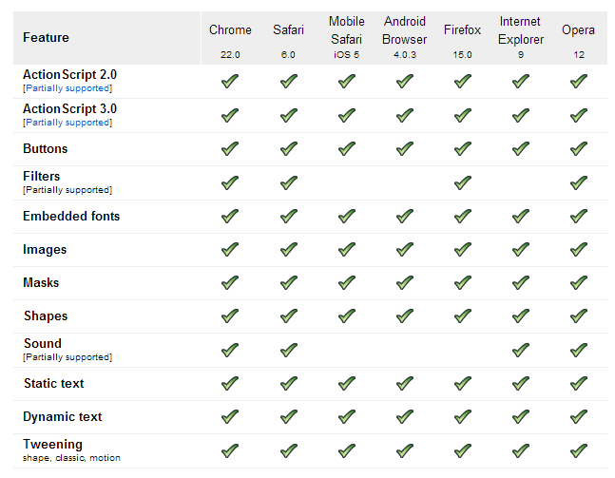

**테스트**<https://swiffypreviews.googleusercontent.com/view/o/f4db0d60-16f1-47fb-8bec-0fc713ff5232/1.html>

* **[swiffy.html]**- 폰트 적용 안됨

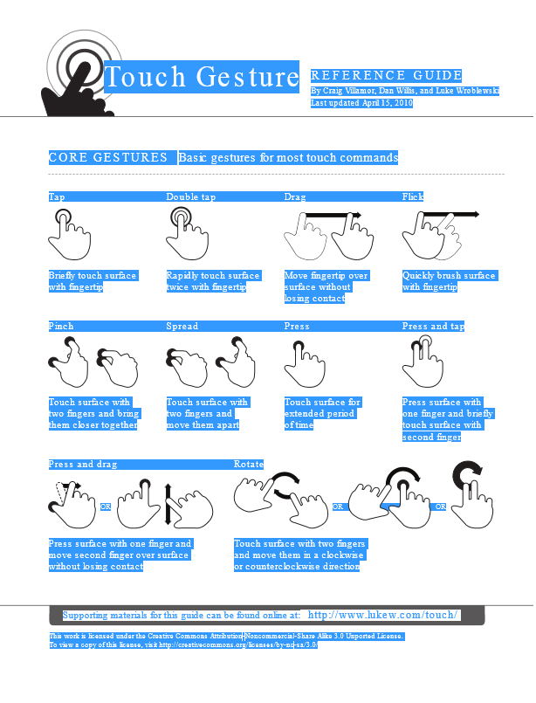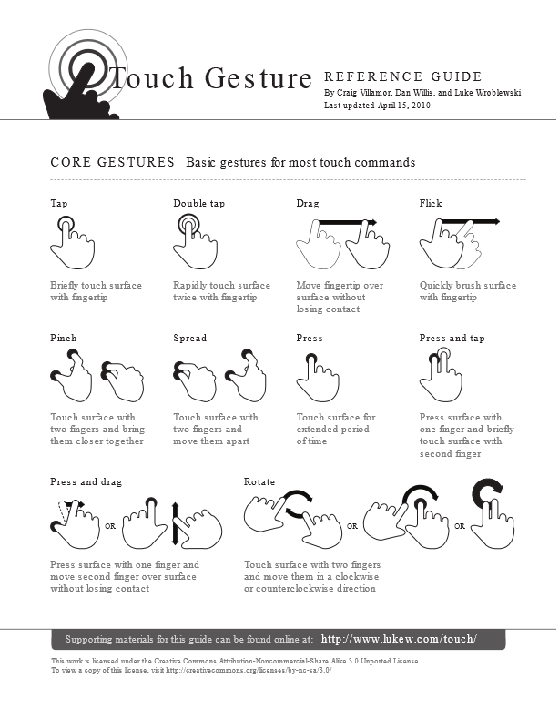

* **[swiffy_js.html]**  
  - swiffyobject (JSON) 데이터를 JS로 파싱하여 표현함  
  - 텍스트 선택 안됨 (테스트 해봐야함)  
  - 폰트 적용됨  
   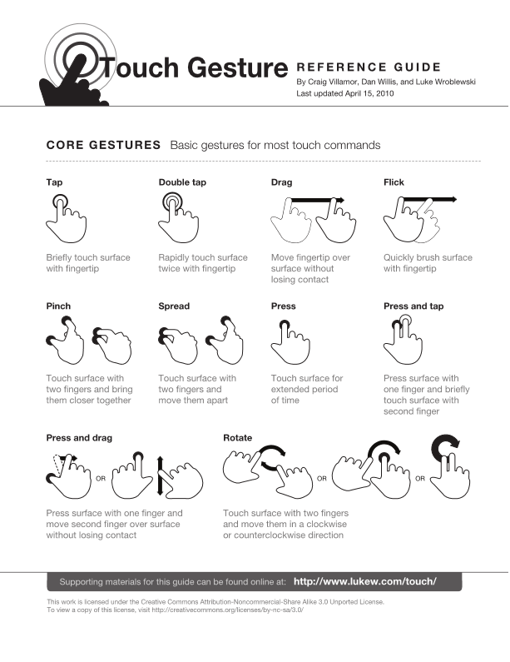
* **[swiffy_svg.htm]**   
  - svg 데이터로 렌더링됨  
  - 안티얼라이싱이 적용되지 않은채로 그려진 것 같음

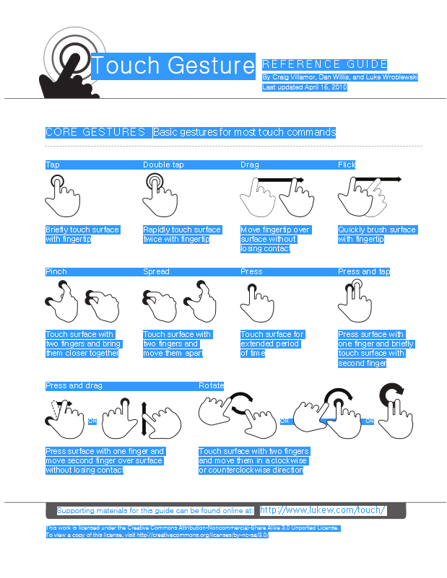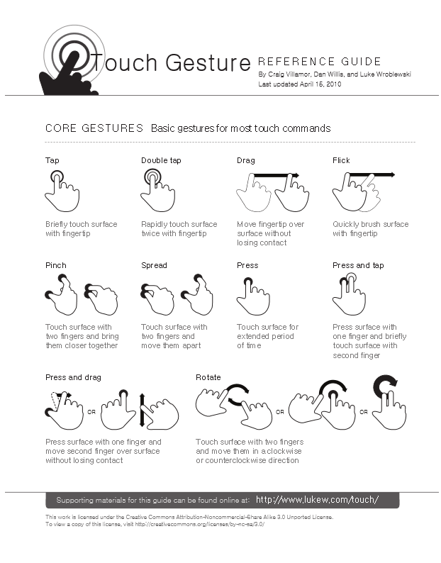

* 출판 결과를 모바일에서 볼수 있음  
  

**유니코드 UCS 와 UTF**

세계 언어를 단일 문자셋으로 만들려는 단체가 2개이다. 하나는 ISO (국제 표준기구 ISO10646)과 소프트웨어 제조사 컨소시엄으로 구성된 유니코드 프로젝트였다.  
이 두 단체는 단일한 코드테이블을 만들려 공동으로 작업했고 UNICODE1.1 == ISO1-646-1:1993 UNICODE 3.0 == ISO10646-1:2000 등과 같이 서로 호환되게 하였지만 양 프로젝트는 서로 독립적으로 존체하며 각자 표준을 독립적으로 발표하고 있다.  
아래는 유니코드 및 UCS에 대한 간략한 설명이다.

* ASCII : 7비트 문자 (American Standard Code for Information Interchange)  
             U+0000 ~ U+007F(ISO 646 IRV)
* Latin-1 : U+0000 ~ U+00FF (ISO 8859-1) Latin-1을 ASCII로 지칭되기도 한다.
* UCS : Universal Charset Set   
            110만개 중 첫 65536개만 사용 (이 영역을 BMP, Basic Multilingul Plane라 지칭)          
           Plane (언어판, 256x256 중 65536개의 코드 묶음) - 유니코드에서는 현재 17개의 언어판 사용
* UCS-2 : 유니코드를 2바이트로 변환 (UCS16) Unicode  
              ISO 10646에 정의  
              0x0000~0xFFFD 까지 사용 이를 BMP (Basic Multilingual Plane)라고 부름  
              U+0000 ~ U+007F : ASCII영역 (ISO 646 IRV)  
              U+0000 ~ U+00FF : Latin-1 (ISO 8859-1)  
              U+E000 ~ U+F8FF 와 BMP 외부 영역은 Reserve됨
* UCS-4 : 유니코드를 4바이트로 변환 (UCS32)   
              ISO 10646에 정의
* UTF : UCS Transfromation Format  
           유니코드를 위한 문자 인코딩 방식
* UTF-8 : 한 글자당 1~4 바이트 사용 (8bit form)  
             1바이트  : ASCII  
             2바이트 : 발음기호가 붙은 라틴문자, 그리스 문자, 키릴 문자, 콥트 문자, 아르메니아 문자, 히브리 문자, 아랍문자  
             3바이트 : 나머지 중 BMP이내의 문자 (한글은 3바이트로 사용)    
             4바이트 : BMP 바깥의 유니코드이며 거의 사용되지 않는다.
* UTF-16 : 한 글자당 2 또는 4바이트 사용  (16-bit form)  
             UCS2를 확정하여 BMP밖의 영역도 표시가 가능하도록 한 Encoding  
             BMP에 속하는 문자는 16비트값으로 인코딩 되고 그 이상의 문자는 32비트로 인코딩
* UTF-32 : UCS-4와 유사 (32bit form)  
            UCS-4 중 0x00000000 ~ 0x0010FFFF 만 문자코드로 간주

**유니코드**UNICODE 1.0 : 1991년 제정  
UNICODE 1.1 : 1993년 (ISO 10646-1:1993)  
UNICODE 2.0 : 1996년 (11172 자의 한글이 포함됨)  
UNICODE 2.1 : 1998년  
UNICODE 3.0 :  2000년 ISO 10646-1:2000  
UNICODE 3.2 : 2002년 ISO 10646-2:2001  
UNICODE 4.0 : 2003년 ISO 10646-3:2003  
UNICODE 4.1 : 2005년  
UNICODE 5.0 : 2006년  
UNICODE 5.1 : 2008년

**Character 정보 검색**

<http://graphemica.com/%EC%9B%90>   
<http://www.fileformat.info/info/unicode/char/c6d0/index.htm>

**Cygwin 설치**

<http://blog.naver.com/swmem_bjm?Redirect=Log&logNo=130144653543>

install이 필요한 목록을 선택한 후 진행한다. (Default 라는 텍스트를 클릭하면 install로 바뀐다.)

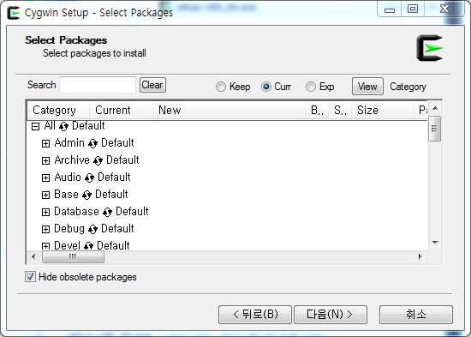

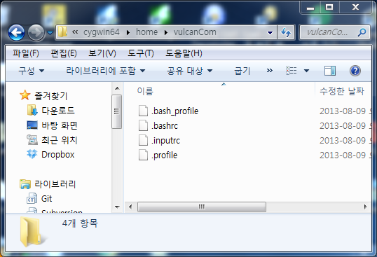

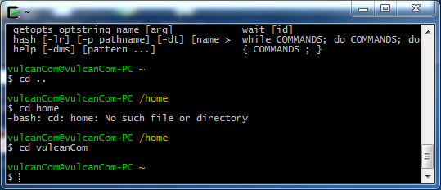

로컬 파일시스템에서 Root 디랙토리를 확인한다. (C:\cygwin64\home\vulcanCom~)

Pdf2svg 다운로드

<http://www.cityinthesky.co.uk/opensource/pdf2svg>

터미널에 다음을 실행하여 컴파일 한다.

$> tar -zxf pdf2svg-0.2.2.tar.gz  
 $> cd pdf2svg-0.2.2  
 $>./configure --prefix=/usr/local  
 $> make  
 $> make install

Exe가 컴파일 되었으면 터미널에서 계속 작업한다. 윈도우 cmd 창에서 작업을 옮기면 exe는 동작하지 않는다. (C:\cygwin64\home\vulcanCom\pdf2svg)

To use

*pdf2svg <input.pdf> <output.svg> [<pdf page no. or "all" >]*

Note: if you specify all the pages you must give a filename with %d in it (which will automatically be replaced by the appropriate page number). E.g.

*pdf2svg input.pdf output_page%d.svg all*

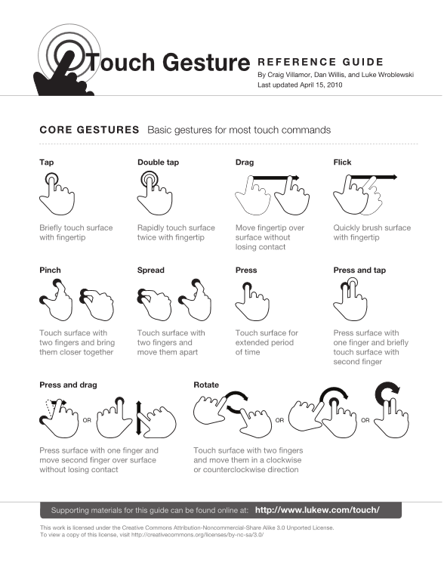

Swiffy_sgv와 비교해볼 것

**Xpdf**

<http://www.foolabs.com/xpdf/download.html>

pdf font embedding : <http://dhdhfl.tistory.com/114>

파싱 라이브러리 : <http://blog.naver.com/fraipan?Redirect=Log&logNo=20109712712>

폰트 추출 :   
<http://sekterra.blog.me/150117769978>   
<http://stackoverflow.com/questions/3488042/how-can-i-extract-embedded-fonts-from-a-pdf-as-valid-font-files>

옵션 : <http://linux.die.net/man/1/pdftotext>

-layout : 모양 유지